
Data Structures and Algorithms
( Course Code: CSC211 )

Name : Muhammad Abdullah
Roll No # FA24-BSE-042
Instructor Name : Sir Atique Ahmed

Assignment # 2
Theory Part

Q#1: E-Commerce Return Management System (Static Stack Implementation)
Major online retailers such as Daraz and Amazon process hundreds of product return requests every hour. The Return Management Department handles these requests in reverse order of arrival to quickly resolve the most recent issues first. Design and implement a static stack (array-based) system that stores customer return requests. Each request includes: • Order ID • Customer Name • Return Reason • Date of Request Operations: 1. pushReturnRequest() – Add a new return request to the stack. 2. popReturnRequest() – Process and remove the latest request. 3. peekLatestRequest() – View the most recent request awaiting review. 4. displayAllRequests() – Display all unprocessed requests. This simulation helps analyze how LIFO operations assist in managing real-time customer service workflows.

Algorithm:
Product Return Request Management using Stack
Step 1: Start
Step 2: Define class Stack
Data members:
- id[5], name[5], reason[5], date[5] (arrays to store return request data)
- top (integer to track top of stack)
Step 3: Initialize Stack (Constructor)
Set top = -1

Function: pushReturnRequest(id, name, reason, date)
Step 4: If top == 4
Display "Stack Overflow"
Return
Step 5: Else
Increment top by 1
Store id, name, reason, date at position top
Display "Data pushed"

Function: popReturnRequest()
Step 6: If top == -1
Display "No requests to process"
Return
Step 7: Else
Display "Deleting latest request"
Print id[top], name[top], reason[top], date[top]
Decrement top by 1

Function: peekLatestRequest()
Step 8: If top == -1
Display "No pending requests"
Return
Step 9: Else
Display "Latest request"
Print id[top], name[top], reason[top], date[top]

Function: displayAllRequest()
Step 10: If top == -1
Display "No pending requests"
Return
Step 11: Else
Display "Submitted Requests:"
For i = top down to 0
Print id[i], name[i], reason[i], date[i]

Main Function
Step 12: Create object s of class Stack
Step 13: Call pushReturnRequest() five times to add requests
Example: (1, "Aima", "didnt like product", "24-09-2024")
Step 14: Call displayAllRequest()
Step 15: Call popReturnRequest()
Step 16: Call displayAllRequest() again
Step 17: Call peekLatestRequest()
Step 18: Stop

OUTPUT
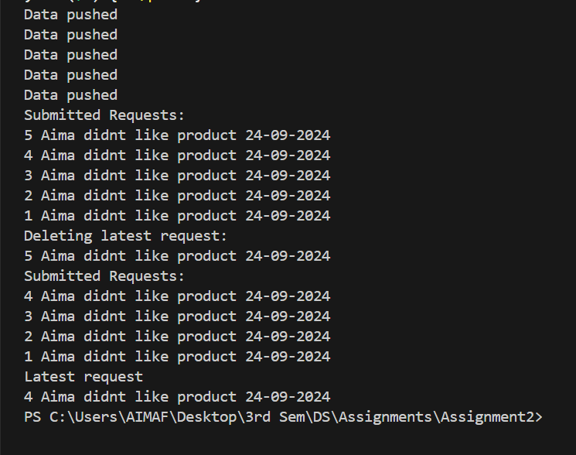

Q#2 : Browser History Navigation Manager (Dynamic Stack Implementation)
Modern browsers (e.g., Google Chrome, Mozilla Firefox) maintain a navigation history that allows users to go back and forth between visited websites. This navigation history internally functions as a stack. Implement a dynamic stack (linked-list-based) to simulate a simplified browser history system. Each node represents a webpage containing: • Page Title • URL • Time Visited Operations: 1. visitPage(url) 2. goBack() 3. viewCurrentPage() 4. displayHistory() This case study demonstrates how browsers use stack principles to manage navigation flow efficiently.

Algorithm:
Browser History Management using Dynamic Stack
Step 1: Start
Step 2: Define class Node
Data members:
- url (string)
- time (string)
- title (string)
- next (Node pointer)
Step 3: Define constructor Node(url, time, title)
- Assign values to url, time, and title
- Set next = nullptr

Define class Stack
Data members:
- head (Node pointer)
- curr (Node pointer)
Step 4: Initialize Stack (Constructor)
Set head = nullptr
Set curr = nullptr

Function: visitPage(url, time, title)
Step 5: Create a new Node newNode with given url, time, and title
Step 6: If head == nullptr
→ Set head = newNode
→ Set curr = newNode
Step 7: Else
→ Set newNode->next = head
→ Set head = newNode
→ Set curr = newNode
Step 8: Display "Visited: [title] ([url]) at [time]"

Function: goBack()
Step 9: If head == nullptr
→ Display "Empty"
→ Return
Step 10: If head->next == nullptr
→ Display "Going back from"
→ Print head->url, head->title, head->time
→ Delete head
→ Set head = nullptr
→ Set curr = nullptr
→ Return
Step 11: Otherwise
→ Set del = head
→ Display "Going back from"
→ Print head->url, head->title, head->time
→ Set head = head->next
→ Delete del
→ Set curr = head

Function: viewCurrentPage()
Step 12: If curr == nullptr
→ Display "Empty"
→ Return
Step 13: Else
→ Display "Current Page is:"
→ Print curr->url, curr->title, curr->time

Function: displayHistory()
Step 14: If head == nullptr
→ Display "Empty"
→ Return
Step 15: Otherwise
→ Display "History is:"
→ Set temp = head
→ While temp != nullptr
Print temp->url, temp->title, temp->time
Set temp = temp->next

Main Function
Step 16: Create object browser of class Stack
Step 17: Call visitPage() three times
(“https://www.google.com”, “10:00 AM”, “Google”)
(“https://www.github.com”, “10:10 AM”, “GitHub”)
(“https://www.youtube.com”, “10:20 AM”, “YouTube”)
Step 18: Call viewCurrentPage()
Step 19: Call displayHistory()
Step 20: Call goBack()
Step 21: Call viewCurrentPage() again
Step 22: Call displayHistory() again
Step 23: Stop

OUTPUT:
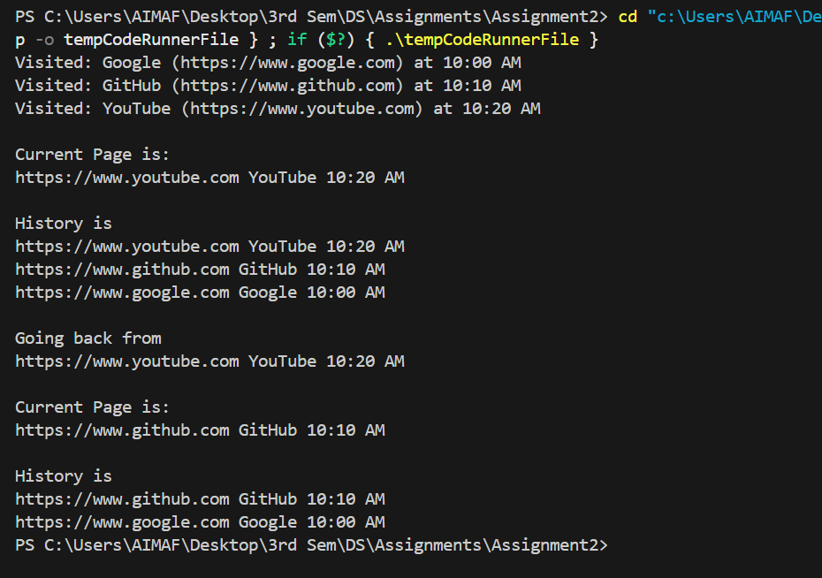

Q#3: : Expression Evaluation in a Scientific Calculator (Application of Stack)
A scientific calculator application developed for engineers must evaluate mathematical expressions entered in postfix (Reverse Polish) notation. Each expression may contain: • Single- or multi-digit operands (non-negative integers) • Arithmetic operators: +, -, *, / Design a stack-based evaluator that computes the result of such expressions. Example: Input → 23-4+567*+* | Output → 141 The evaluator should process each character sequentially, pushing operands and applying operators as they appear.

CODE:
Algorithm: Postfix Expression Evaluation using Stack
Step 1: Start
Step 2: Declare a stack of integers named st
Step 3: Declare variables op1, op2, result
Step 4: Input the postfix expression exp from the user
Step 5: Find the length of the expression and store it in variable l
Step 6: For each character exp[i] from index 0 to l - 1, repeat Steps 7–15

If the current character is an operand (a digit):
Step 7: Convert the character to integer → num = exp[i] - '0'
Step 8: Push num onto the stack

*If the current character is an operator (+, -, , /):
Step 9: Check if the stack has at least two operands (st.size() ≥ 2)
If yes, continue; otherwise, ignore
Step 10: Pop top element from the stack → op2 = st.top() → st.pop()
Step 11: Pop next top element from the stack → op1 = st.top() → st.pop()
Step 12: If operator is '+', then result = op1 + op2
Step 13: If operator is '-', then result = op1 - op2
Step 14: If operator is '*', then result = op1 * op2
Step 15: If operator is '/', then result = op1 / op2
Step 16: Push result back onto the stack

Step 17: After the loop ends, the final result will be at the top of the stack
Step 18: Display "Result: " followed by st.top()
Step 19: Stop

OUTPUT: 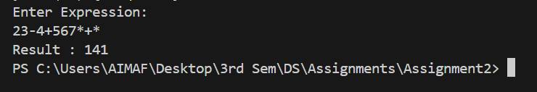

Q#4: Warehouse Inventory Stacking Simulator (Application of Stack)
A logistics company uses robotic arms to stack and unstack boxes in a warehouse. To maintain safety, no heavier box may be placed on a lighter one. When a new box arrives: • If it’s lighter than the top box → push it. • If it’s heavier → repeatedly pop boxes until a heavier or equal box is found, then push it. Display the final stack configuration from top (lightest) to bottom (heaviest). This models warehouse stacking algorithms used in robotic sorting.

Algorithm:
Warehouse Inventory Stacking Simulator using Stack
Step 1: Start
Step 2: Declare a stack of integers named st
Step 3: Declare integer variables length and num
Step 4: Display message "How many boxes you want to enter?"
Step 5: Input the number of boxes → store in length
Step 6: Repeat Steps 7–13 for each box from i = 0 to length - 1

For each box:
Step 7: Display "Enter weight of box (i + 1):"
Step 8: Input num (weight of the box)
Step 9: If the stack is empty OR the top of stack (st.top()) is heavier than num,
→ Push num onto the stack
Step 10: Else (the new box is heavier than the top box),
→ While stack is not empty AND top of stack is lighter than num,
Pop the top box (remove it)
Step 11: After the loop ends, push num onto the stack

After all boxes are processed:
Step 12: Display message "Final stack (top to bottom):"
Step 13: While the stack is not empty,
→ Print the top element (box weight)
→ Pop the top box
Step 14: Stop

OUTPUT:
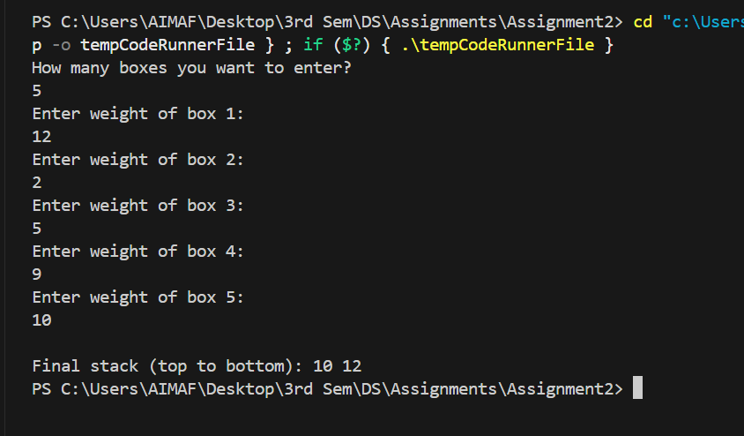

Q#5: Airport Shuttle Ticketing Queue (Static Queue Implementation)
At large airports, a shuttle service transports passengers between terminals. Passengers queue up to buy tickets following the first come, first-served rule. Design a static queue (array-based) that manages ticket sales. Each passenger record includes: • Name • Destination Terminal • Ticket Type (VIP/Regular) Operations: 1. enqueuePassenger() 2. dequeuePassenger() 3. displayQueue() 4. isFull()/isEmpty() This queue system mirrors real airport automation software used for passenger flow management.

Algorithm:
Step 1: Start
Step 2: Initialize Queue
- Define a class Queue with:
  - Constant integer size = 5
  - Arrays: name[size], destination[size], ticketType[size]
  - Integers front and rear initialized to -1

Step 3: Define isFull()
- Check if rear == size - 1
- If true → Queue is full
- Else → Queue not full

Step 4: Define isEmpty()
- Check if front == -1 OR front > rear
- If true → Queue is empty
- Else → Queue not empty

Step 5: Define enqueuePassenger(name, destination, ticketType)
- If isFull() → Display "Queue Overflow"
- Else
  - Increment rear by 1
  - If front == -1, set front = 0
  - Store:
    - this->name[rear] = name
    - this->destination[rear] = destination
    - this->ticketType[rear] = ticketType
  - Display "Data pushed"

Step 6: Define dequeuePassenger()
- If isEmpty() OR front > rear → Display "No data present"
- Else
  - Display "Dequeuing 1st Passenger details:"
  - Print name[front], destination[front], ticketType[front]
  - Increment front by 1

Step 7: Define displayQueue()
- If front == -1 → Display "No Data stored"
- Else
  - Display "Data is given below:"
  - For each passenger from front to rear, print:
    - name[i], destination[i], ticketType[i]

Step 8: Main Function
- Create object q of class Queue
- Call enqueuePassenger() several times to add passengers
- Call displayQueue() to show current queue
- Perform multiple dequeuePassenger() operations
- Display queue after each dequeue

Step 9: End

OUTPUT:
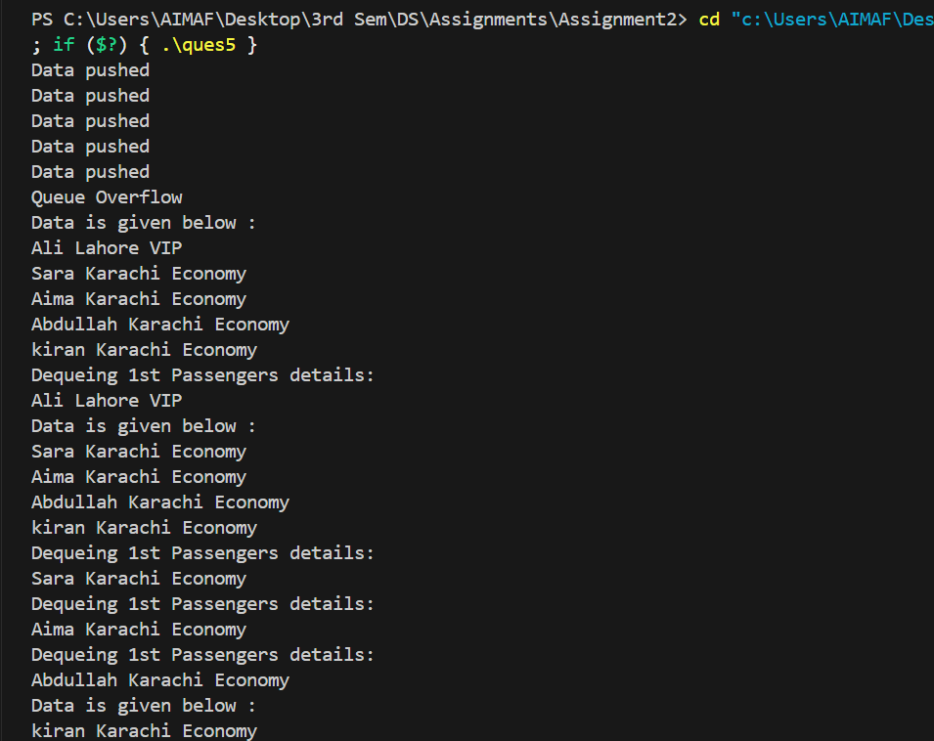

Q#6: Hospital Appointment Scheduling System (Dynamic Queue Implementation)
Hospitals often need to dynamically manage patient appointments as new cases arrive. Develop a dynamic queue (linked-list-based) for scheduling patient consultations. Each record stores: • Patient Name • Patient ID • Doctor’s Name • Appointment Time Operations: 1. addPatient() 2. callNextPatient() 3. displayAllAppointments() This simulation reflects real-time queuing logic used in hospital management systems to improve patient flow.

Algorithm:

Step 1: Start

Step 2: Define Node class
Each node represents one patient appointment and contains:
- patientName → name of the patient
- patientId → unique ID of the patient
- docName → doctor’s name
- time → appointment time
- next → pointer to the next node
Initialize all data members using a constructor.

Step 3: Define Queue class
The queue manages appointments dynamically using linked nodes.
It contains:
- front → pointer to the first patient (next to be served)
- rear → pointer to the last patient (latest added)
Initialize front and rear as nullptr in the constructor.

Step 4: Define addPatient(name, id, docName, time)
- Create a new node using the given data.
- If rear == nullptr (queue empty), set both front and rear to the new node.
- Else, link the new node at the end (rear->next = newNode) and update rear = newNode.
- Display message: "Patient added successfully."

Step 5: Define callNextPatient()
- If front == nullptr, display "No patients in the queue."
- Else:
  - Display the details of the patient at the front.
  - Move front to the next node (front = front->next).
  - Delete the old front node.
  - If front becomes nullptr, set rear = nullptr.

Step 6: Define displayAllAppointments()
- If front == nullptr, display "No appointments available."
- Else:
  - Traverse from front to rear using a temporary pointer.
  - Print all patient records: name, ID, doctor’s name, and time.

Step 7: In main() function
- Create a Queue object q.
- Call addPatient() three times to add example appointments.
- Display all appointments.
- Call callNextPatient() to serve the next patient.
- Display remaining appointments again.

Step 8: End

OUTPUT:
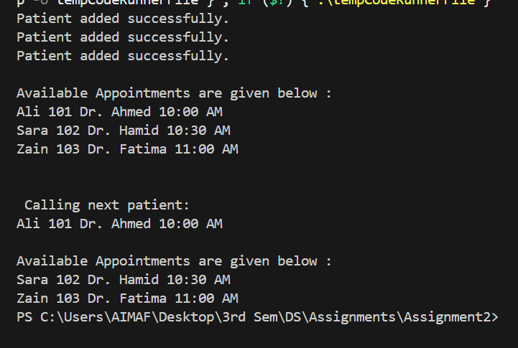

Q#7: Smart Parking Lot Management System (Circular Queue Application)
A smart parking lot with fixed slots uses a circular queue to track parked cars and efficiently reuse empty slots. Each car record includes: • Car Number • Arrival Time • Slot Number Operations: 1. parkCar() 2. removeCar() 3. displayParkingStatus() This case study represents how smart parking systems optimize limited parking spaces using circular data structures.

Algorithm

Step 1: Start

Step 2: Define CircularQueue class
Declare the following data members:
- carNumber[] → stores car numbers
- arrivalTime[] → stores arrival time of each car
- slotNum[] → stores parking slot number
- f → index of the front car in queue
- r → index of the rear car in queue
- currSize → current number of parked cars
- cap → total parking capacity
Initialize in constructor:
- f = 0, r = -1, currSize = 0

Step 3: Define parkCar(carNumber, arrivalTime, slotNum)
- If currSize == cap, display "Parking is Full" and exit function.
- Else:
  - Move rear pointer using circular logic: r = (r + 1) % cap.
  - Store car details at index r.
  - Increment currSize.

Step 4: Define removeCar()
- If queue is empty (currSize == 0), display "Parking is empty."
- Else:
  - Move front pointer using circular logic: f = (f + 1) % cap.
  - Decrease currSize.
  - If all cars removed (currSize == 0), reset f = 0 and r = -1.

Step 5: Define empty()
Return true if currSize == 0, else false.

Step 6: Define displayParkingStatus()
- If queue empty, display "Parking is empty."
- Else:
  - Loop i from 0 to currSize - 1.
  - Calculate circular index: index = (f + i) % cap.
  - Display carNumber[index], arrivalTime[index], and slotNum[index].

Step 7: In main() function
- Create a circular queue pq with capacity 3.
- Call parkCar() to add cars with details.
- Call displayParkingStatus() to show parked cars.
- Call removeCar() to remove the front car.
- Add more cars and repeat to test circular behavior.
- Display final parking status.

Step 8: End

OUTPUT:
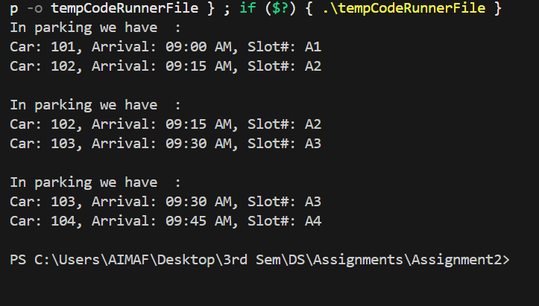

Q#8: Train Compartment Reservation System (Double-Ended Queue Application)
The national railway’s reservation system must handle both VIP and regular passengers. VIP passengers get front-end bookings, while regular passengers are queued from the rear end. Design a double-ended circular queue (deque) to manage compartment reservations. Each record includes: • Passenger Name • Category (VIP/Regular) • Seat Number Operations: 1. bookAtFront() 2. bookAtRear() 3. cancelFromFront()/cancelFromRear() 4. displayAllReservations() This models how transportation systems dynamically prioritize customers without disrupting existing orders.

Algorithm

Step 1: Start

Step 2: Declare global arrays
- name[5] → stores passenger names
- category[5] → stores passenger categories (VIP or Regular)
- seatNum[5] → stores seat numbers
Also declare:
- s → current number of passengers
- n → total capacity of queue (5)

Step 3: Define function empty()
Return true if s == 0, else false.

Step 4: Define function isFull()
Return true if s == n, else false.

Step 5: Define function bookAtFront(name, category, seatNum)
- If queue is full, stop booking.
- If queue is empty:
  - Insert passenger details at position 0.
- Else:
  - Shift all elements one position to the right.
  - Insert new passenger details at the front (index 0).
- Increment s by 1.

Step 6: Define function bookAtRear(name, category, seatNum)
- If queue is full, display “No more bookings — list is full!” and stop.
- Else, insert new passenger details at position s.
- Increment s by 1.

Step 7: Define function cancelFromFront()
- If queue is empty, display “Empty Already”.
- Else:
  - Shift all elements one position to the left (removing the first entry).
  - Decrement s by 1.
  - Display “First booking is cancelled!”.

Step 8: Define function cancelFromRear()
- If queue is empty, display “Empty Already”.
- Else:
  - Simply decrement s by 1.
  - Display “Last booking is cancelled!”.

Step 9: Define function displayAllReservations()
- If queue is empty, display “Empty Already”.
- Else:
  - Loop through all stored records (0 to s-1) and display:
    - name[i], category[i], seatNum[i].

Step 10: In main() function
- Create a menu-driven program with options:
  - 1 → Book at Front (VIP)
  - 2 → Book at Rear (Regular)
  - 3 → Cancel from Front
  - 4 → Cancel from Rear
  - 5 → Display All Reservations
  - 0 → Exit
- Use switch statement to perform corresponding operations.
- Repeat menu until the user chooses Exit (0).

Step 11: End

OUTPUT:
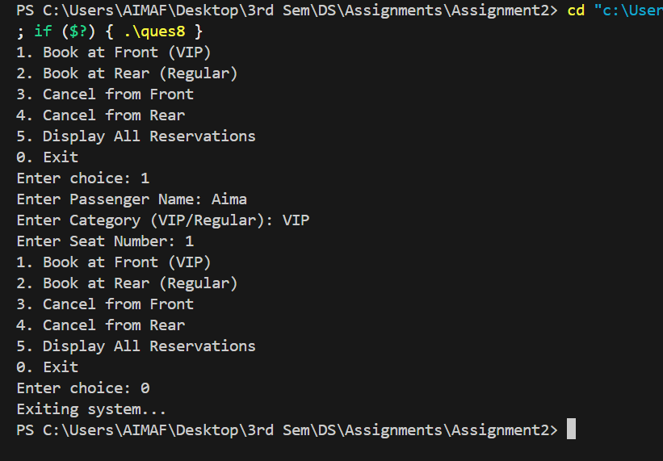

Q#9: Emergency Room Patient Management (Priority Queue Application)
In a hospital Emergency Room (ER), patients are triaged based on urgency levels (1=Critical, 4=Low). Implement a priority queue that maintains patients according to priority. Each record includes: • Patient ID • Name • Condition Description • Priority Level Simulate arrivals in order 4,1,3,2 and ensure they are treated in the order 1→2→3→4. This demonstrates how hospital triage systems manage patient queues for optimal treatment sequencing.

Algorithm:
- Problem Definition
The objective is to manage hospital patients based on their urgency using a min-priority queue.
Lower priority number means higher urgency (1 = most critical, 4 = least urgent).
Patients should be treated in the order 1 → 2 → 3 → 4.
- Input
Each patient record contains:
• Patient ID
• Name
• Condition Description
• Priority Level (1 to 4)
- Output
• Display of patient queue after insertions
• Message showing the patient being attended (deleted)
• Display of updated queue after deletion
• Display of next critical patient using peek
- Variables Used
id[] – stores patient IDs
name[] – stores patient names
description[] – stores patient conditions
priority[] – stores priority levels
s – current queue size
n – maximum queue size (4)
- Steps of the Algorithm
Step 1: Initialize Data
Set s = 0 and n = 4.
Step 2: Check Queue Status
empty() → returns true if s == 0
isFull() → returns true if s == n
Step 3: Insert Operation
Function: insert(int iD, string n, string d, int p)
- If queue is full, print “Queue is Full” and return.
- Set index i = s - 1.
- While i >= 0 and priority[i] > p:
  - Shift all elements one position forward (id, name, description, priority).
- Insert new patient at correct position:
id[i + 1] = iD
name[i + 1] = n
description[i + 1] = d
priority[i + 1] = p
- Increment s.
(This ensures queue is ordered by priority.)
Step 4: Delete Operation
Function: deleteVal()
- If queue is empty, print “Queue is empty”.
- Otherwise:
  - Display “Critical patient [id name description] is now attended.”
  - Shift all remaining elements left by one position.
  - Decrease s by 1.
Step 5: Peek Operation
Function: peek()
Display first element (id[0], name[0], description[0]) as current critical patient.
Step 6: Display Operation
Function: display()
Print all patients with their details and priorities.
Step 7: Main Function
- Insert patients:
insert(41, "Aima", "Kidding", 4)
insert(42, "Amna", "oho", 1)
insert(43, "Eman", "ops", 2)
insert(44, "Asma", "yaar", 3)
- Call display() – shows queue sorted by priority (1, 2, 3, 4).
- Call deleteVal() – removes patient with priority 1.
- Call display() – shows remaining patients.
- Call peek() – shows next critical patient.
- Example Execution
Insertion Order: 4, 1, 2, 3
Resulting Queue: 1, 2, 3, 4
After one deletion → queue becomes 2, 3, 4
Peek shows next critical patient with priority 2.
- Time Complexity
Insertion: O(n)
Deletion: O(n)
Peek: O(1)

OUTPUT:
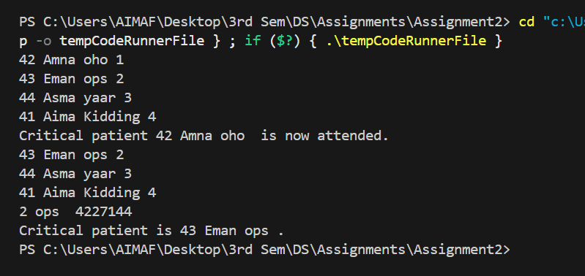

Q#10: Food Delivery Dispatch System (Application of Queue)
A food delivery service (like Foodpanda) must assign orders to riders in real time. Each order includes: • Order ID • Restaurant Name • Customer Address • Item List • Preparation Time • Order Time Operations: 1. addOrder() – Insert at front if quick items only, else at rear. 2. dispatchOrder() 3. viewNextOrder() 4. displayAllOrders() 5. cancelOrder(orderID) This models the dispatch logic of real delivery systems, balancing quick orders and high-priority deliveries using queue operations.

Algorithm:
- Problem Definition
A food delivery service manages real-time order assignments to riders.
VIP or “quick” orders are added to the front, while regular orders are added to the rear of the queue.
The system allows dispatching, viewing, displaying, and canceling orders efficiently using a double-ended queue (deque).
- Input
Each order includes:
• Order ID
• Restaurant Name
• Customer Address
• Item List
• Preparation Time
• Order Time
• Order Type (quick / regular)
- Output
• Displays all active orders
• Shows the next order to dispatch
• Cancels an order by ID
• Confirms dispatched or canceled orders
- Data Structures and Variables
Node structure fields:
- id : integer (Order ID)
- name : string (Restaurant Name)
- address : string (Customer Address)
- itemList : string (List of items)
- prepTime : string (Preparation time)
- orderTime : string (Order placement time)
- next, prev : pointers to link nodes
Queue pointers:
- head : points to the first node (front of queue)
- tail : points to the last node (rear of queue)
- Steps of the Algorithm
Step 1: Initialize
Set head = tail = NULL.
Step 2: Add Order (addOrder)
- Create a new node using given order details.
- If queue is empty, set both head and tail to the new node.
- If order type is “quick”, insert at the front:
  - Set newNode->next = head
  - head->prev = newNode
  - head = newNode
- Otherwise, insert at the rear:
  - tail->next = newNode
  - newNode->prev = tail
  - tail = newNode
Step 3: Dispatch Order (dispatchOrder)
- If queue is empty, display “Empty”.
- Otherwise, remove node from the front (head).
  - If only one node, set head = tail = NULL.
  - Else, move head to head->next and set head->prev = NULL.
- Display message: “Dispatched Order ID: [id]”.
Step 4: View Next Order (viewNextOrder)
- If queue is empty, print “No orders in queue”.
- Otherwise, display all details of the head node (front order).
Step 5: Display All Orders (displayAllOrders)
- If queue is empty, print “No orders to display”.
- Otherwise, traverse from head to tail:
  - Print each order’s ID, name, address, item list, preparation time, and order time.
Step 6: Cancel Order (cancelOrder)
- If queue is empty, display “No orders to cancel”.
- If head node’s ID matches the given orderID:
  - Move head = head->next and update head->prev = NULL.
  - If queue becomes empty, set tail = NULL.
  - Print “Order cancelled (was at front)”.
- Else, traverse to find the matching node:
  - If not found, print “Order ID not found”.
  - If found at tail, move tail = tail->prev and set tail->next = NULL.
  - If found in middle, adjust previous and next pointers to unlink the node.
  - Delete the node and print appropriate cancellation message.
Step 7: Main Menu Operations
- Display menu with options:
  - Add Order
  - Dispatch Order
  - View Next Order
  - Display All Orders
  - Cancel Order
  - Exit
- Perform corresponding functions based on user input until exit.
- Example Execution
- Add orders with types: quick and regular.
- Quick orders appear at the front.
- Dispatch removes the oldest (front) order.
- Cancel removes a specific order by ID.
- Display shows all current orders.
- Time Complexity
Add Order: O(1)
Dispatch Order: O(1)
Cancel Order: O(n)
Display Orders: O(n)
View Next Order: O(1)

OUTPUT:
